MANGOCHI CATHOLIC DIOCESE MOCK EXAMINATIONS
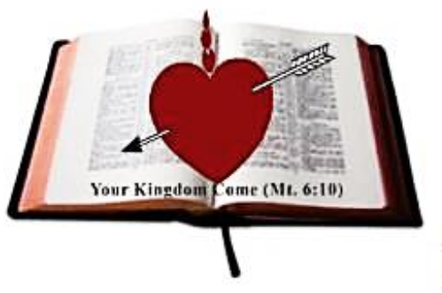
2025 MALAWI SCHOOL CERTIFICATE OF EDUCATION
CHEMISTRY
Thursday, 29 May 2025 Subject Number: M038/II
Time Allowed: 2 hours
10:00 am onwards
PAPER II
(40 marks)
Question  Number | Tick if answered | Do not write in these columns
1
2
3
4
Instructions
- This paper contains 6 printed pages. Please check
- Before beginning. Fill in your Examination Number at the top of each page of the question paper
- Write your answers on the question paper
- This paper consists of two sections, A and B
- Section A consists of two descriptive questions on practical work to be answered in 1 hour. Marks will be given for accurate and orderly presentation of facts supported by relevant diagrams
- In section B there are two practical questions to be answered in 1 hour.
- You should spend 30 minutes on each question.
The 30 minute period allowed for each question includes
3 minutes to tidy up the apparatus and have checked by the supervisor.
- Marks for section B will be given for observation, accuracy and interpretation of results
- In the table provided on this page, tick against the question number you have answered

© 2025 MH DIOCESE Turn Over
Section A (20 marks)
1. With the aid of a well labeled diagram, describe an experiment that could be done to investigate whether dissolution of sodium hydroxide in water is an exothermic or endothermic reaction.

______________________________________________________________________________
______________________________________________________________________________
______________________________________________________________________________
______________________________________________________________________________
______________________________________________________________________________
______________________________________________________________________________
______________________________________________________________________________
______________________________________________________________________________
______________________________________________________________________________
______________________________________________________________________________
______________________________________________________________________________
______________________________________________________________________________
______________________________________________________________________________
(10 marks)
2. Describe an experiment that could be conducted to determine the percentage of water in hydrated copper sulphate.
______________________________________________________________________________
______________________________________________________________________________
continued/…
______________________________________________________________________________
______________________________________________________________________________
______________________________________________________________________________
______________________________________________________________________________
______________________________________________________________________________
______________________________________________________________________________
______________________________________________________________________________
______________________________________________________________________________
______________________________________________________________________________
______________________________________________________________________________
______________________________________________________________________________
______________________________________________________________________________
______________________________________________________________________________
______________________________________________________________________________
______________________________________________________________________________
______________________________________________________________________________
______________________________________________________________________________
______________________________________________________________________________
______________________________________________________________________________
______________________________________________________________________________
______________________________________________________________________________
______________________________________________________________________________
______________________________________________________________________________
(10 marks)
SECTION B (20 marks)
- You are provided with unknown compounds labeled P, Q and R in dropper bottles which are ethanol, ethanoic acid and hexane but not necessarily in that order, 3 test tubes in a test tube rack, blue litmus paper and distilled water in a dropper bottle.
    - Put 10 drops of compounds P, Q and R in the three test tubes.
    - Add 5 drops of distilled water in each test tube containing the compounds P, Q and R.
    - Record your observations in table 1.

continued/…
Test
Solution | With distilled water | With litmus Paper
P
Q
R
Table 1
(6 marks)
    - Rinse the test tubes with distilled water.
    - Repeat step a.
    - Take 3 pieces of blue litmus paper and dip in each test tube.
    - Observe the colour change on the litmus paper.
    - Identify compounds P, Q and R.
P____________________________________________________________________
Q____________________________________________________________________ R____________________________________________________________________
(3 marks)
i. State any one source of error in the experiment.
_____________________________________________________________________
_____________________________________________________________________
(1 mark)

- You are provided with oxides labeled X, Y and Z in Petri dishes, 3 beakers, hydrochloric acid solution (HCl), sodium hydroxide solution(NaoH), spatula, stirring rod, measuring cylinder and distilled water.
  - Scoop small amount (of the spatula) of oxides X, Y and Z in each beaker.
  - Put 10 cm³ of hydrochloric acid solution in beaker containing oxides X, Y and Z
  - Stir gently.
  - Record your observations in table 2.

continued/…

Oxide | Hydrochloric acid (HCl) | Sodium hydroxide (NaOH)
X
Y
Z
Table 2
(6 marks)
  - Rinse the beakers with distilled water.
  - Repeat steps (a) to (d) by using sodium hydroxide solution.
  - Classify the oxides as acidic, basic and amphotoric.
X______________________________________________________________
Y______________________________________________________________
Z______________________________________________________________
(3 marks)
  - State any one source of error in the experiment.
___________________________________________________________________________
___________________________________________________________________________
(1 mark)

END OF QUESTION PAPER
NB: This paper contains 5 printed Pages.

